Consider Tables:

1. Borrower (Roll_no, Name, Date of Issue, Name of Book, Status)

2. Fine (Roll_no, Date, Amt)

* Accept Roll_no and Name of Book from user.
* Check the number of days (from date of issue).
* If days are between 15 to 30 then fine amount will be Rs 5per day.
* If no.of days>30, per day fine will be Rs 50 per day & for days less than 30, Rs 5 per day.
* After submitting the book, status will change from I to R.
* If condition of fine is true, then details will be stored into fine table.
* Also handles the exception by named exception handler or user define exception handler.

**PL/SQL Block: -**

CREATE TABLE Borrower (Rollno NUMBER(4), Name VARCHAR2(20), DateofIssue DATE, NameofBook VARCHAR2(30), Status VARCHAR2(10));

INSERT INTO Borrower VALUES (14, 'Ram', TO_DATE('2024-09-10', 'YYYY-MM-DD'), 'DBMS', 'I');

INSERT INTO Borrower VALUES (27, 'Soham', TO_DATE('2024-09-10', 'YYYY-MM-DD'), 'Theory of Computation', 'I');

INSERT INTO Borrower VALUES (34, 'Mohan', TO_DATE('2024-09-10', 'YYYY-MM-DD'), 'Computer Networks', 'I');

INSERT INTO Borrower VALUES (48, 'Om', TO_DATE('2024-09-10', 'YYYY-MM-DD'), 'SPOS', 'I');

CREATE TABLE Fine (Rollno NUMBER(4), Dates DATE, Amount NUMBER(10));

CREATE OR REPLACE PROCEDURE calc_Fine( r IN NUMBER, b IN VARCHAR2)

IS

doi Borrower.DateofIssue%TYPE;

diff NUMBER;

fine_amount NUMBER := 0;

BEGIN

SELECT DateofIssue INTO doi FROM Borrower WHERE Rollno = r AND NameofBook = b;

diff := TRUNC(SYSDATE) - TRUNC(doi);

IF diff BETWEEN 15 AND 30 THEN

fine_amount := diff * 5;

ELSIF diff > 30 THEN

fine_amount := 30 * 5 + (diff - 30) * 50;

END IF;

IF fine_amount > 0 THEN

INSERT INTO Fine (Rollno, Dates, Amount) VALUES (r, SYSDATE, fine_amount);

END IF;

COMMIT;

EXCEPTION

WHEN NO_DATA_FOUND THEN

DBMS_OUTPUT.PUT_LINE('No such borrower or book found.');

WHEN OTHERS THEN

DBMS_OUTPUT.PUT_LINE('Error: ' || SQLERRM);

END;

/

CREATE OR REPLACE PROCEDURE submit( r IN NUMBER)

IS

BEGIN

UPDATE Borrower SET Status = 'R' WHERE Rollno = r;

DELETE FROM Fine WHERE Rollno = r;

COMMIT;

EXCEPTION

WHEN OTHERS THEN

DBMS_OUTPUT.PUT_LINE('Error: ' || SQLERRM);

END;

/

BEGIN

calc_Fine(14, 'DBMS');

calc_Fine(27, 'Theory of Computation');

calc_Fine(34, 'Computer Networks');

calc_Fine(48, 'SPOS');

END;

/

SELECT * FROM Borrower;

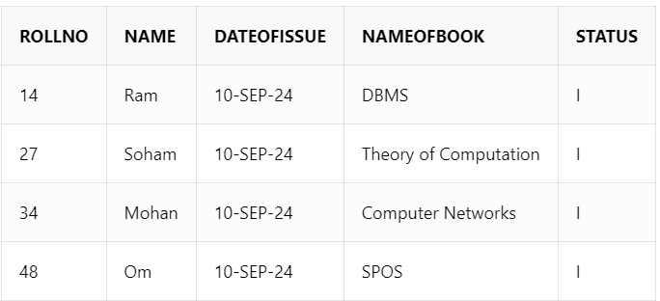

SELECT * FROM Fine;

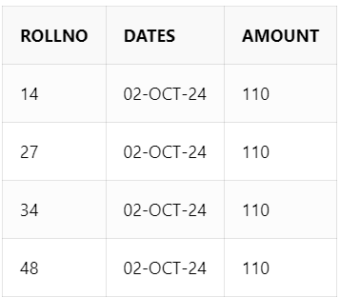

BEGIN

submit(14);

submit(27);

submit(34);

submit(48);

END;

/

SELECT * FROM Borrower;

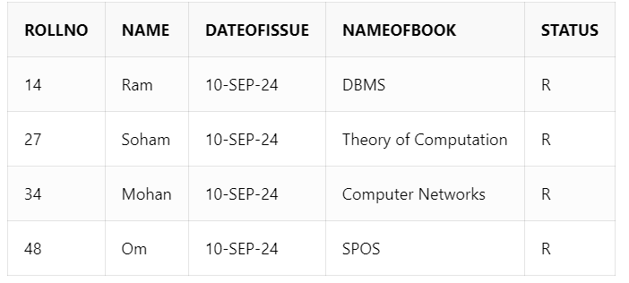

SELECT * FROM Fine;

output:-



Q2. Write a **PL/SQL code block** to calculate the area of a circle for a value of radius varying from 5 to 9. Store the radius and the corresponding values of calculated area in an empty table named areas, consisting of two columns, radius and area.

**PL/SQL Block: -**

CREATE TABLE areas (radius NUMBER(5),area NUMBER(10, 2));

DECLARE

r NUMBER(5);

a NUMBER(10, 2);

pi CONSTANT NUMBER := 3.14159;

BEGIN

FOR r IN 5..9 LOOP

a := pi * r * r;

INSERT INTO areas (radius, area) VALUES (r, a);

END LOOP;

END;

/

SELECT * FROM areas;

